Muhammad fadillah

1207070075

TRANSFORMASI CITRA

1. Transformasi Twirl

import matplotlib.pyplot as plt

import cv2

from cv2 import data

from skimage.transform import swirl

image = cv2.imread("gambar/tesla.jpg")

swirled = swirl(image, rotation=0, strength=10,radius=120)

fig, (ax0, ax1) = plt.subplots(nrows=1, ncols=2,

figsize=(5, 5),

 sharex=True,

sharey=True)

ax0.imshow(image, cmap=plt.cm.gray)

ax0.axis('off')

ax1.imshow(swirled, cmap=plt.cm.gray)

ax1.axis('off')

plt.show()

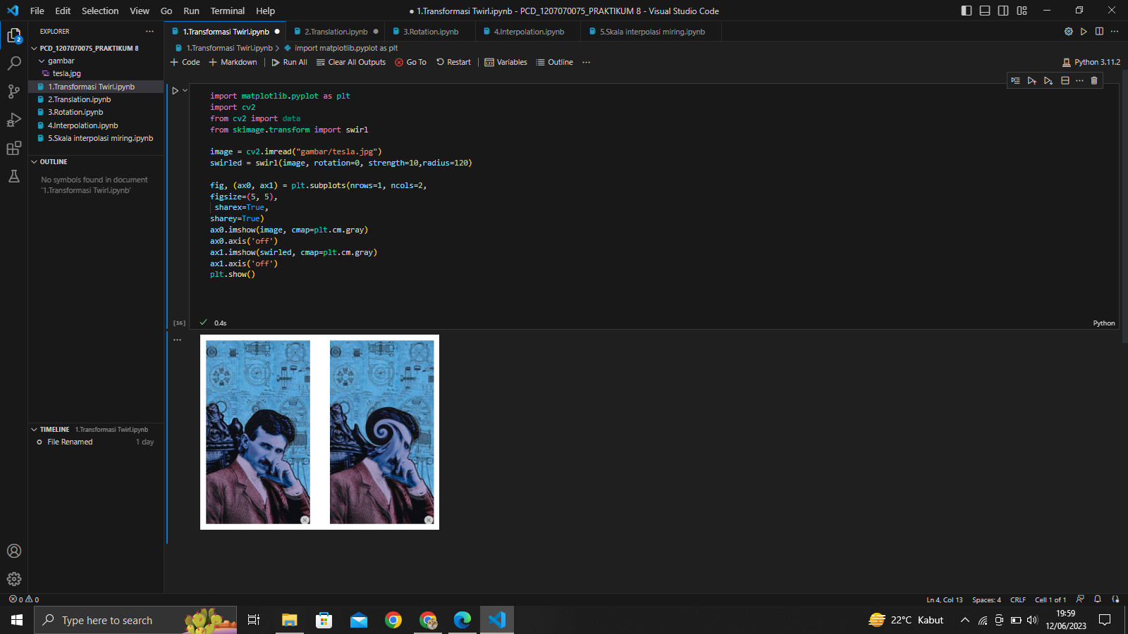

1. Translation

import cv2 as cv

import numpy as np

import matplotlib.pyplot as plt

image = cv.imread("gambar/tesla.jpg")

h, w = image.shape[:2]

half_height, half_width = h//8, w//15

transition_matrix = np.float32([[1, 0, half_width], [0, 1, half_height]])

img_transition = cv.warpAffine(image, transition_matrix, (w, h))

plt.imshow(cv.cvtColor(img_transition, cv.COLOR_BGR2RGB))

plt.title("Translation")

plt.show()

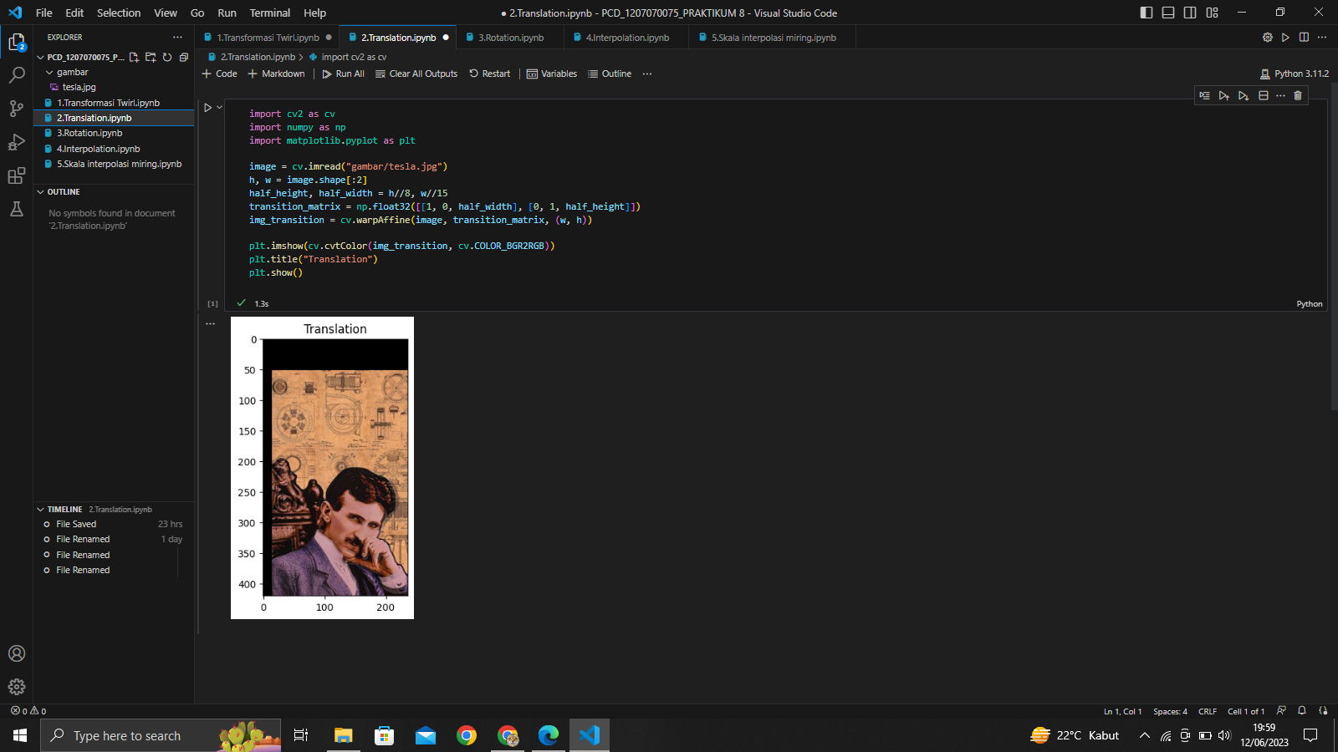

1. Rotation

import cv2 as cv

import numpy as np

import matplotlib.pyplot as plt

image = cv.imread("gambar/tesla.jpg")

h, w = image.shape[:2]

rotation_matrix = cv.getRotationMatrix2D((w/2, h/2), -180, 0.5)

rotated_image = cv.warpAffine(image, rotation_matrix, (w, h))

plt.imshow(cv.cvtColor(rotated_image, cv.COLOR_BGR2RGB))

plt.title("Rotation")

plt.show()

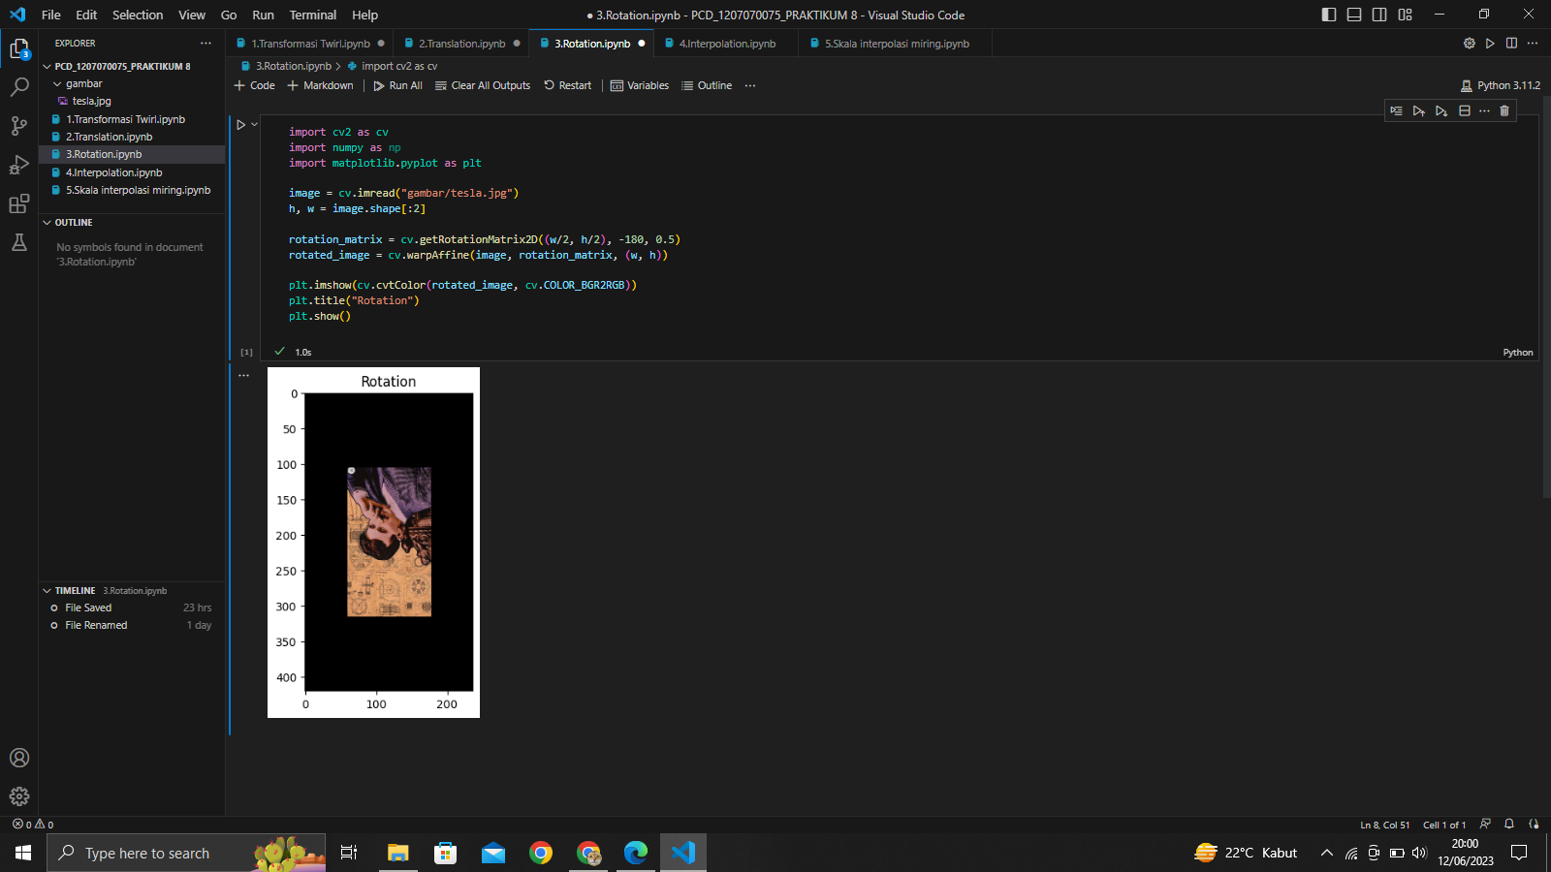

1. Interpolation

import mahotas as mh

import numpy as np

import matplotlib.pyplot as plt

regions = np.zeros((8, 8), bool)

regions[:3, :3] = 1

regions[6:, 6:] = 1

labeled, nr_objects = mh.label(regions)

plt.imshow(labeled, interpolation='nearest')

plt.show()

regions = np.zeros((8, 8), bool)

regions[:3, :3] = 1

regions[6:, 6:] = 1

labeled, nr_objects = mh.label(regions, np.ones((3,3), bool))

sizes = mh.labeled.labeled_size(labeled)

print('Background size:', sizes[0])

print('Size of first region:', sizes[1])

array = np.random.random_sample(regions.shape)

sums = mh.labeled_sum(array, labeled)

print('Sum of first region:', sums[1])

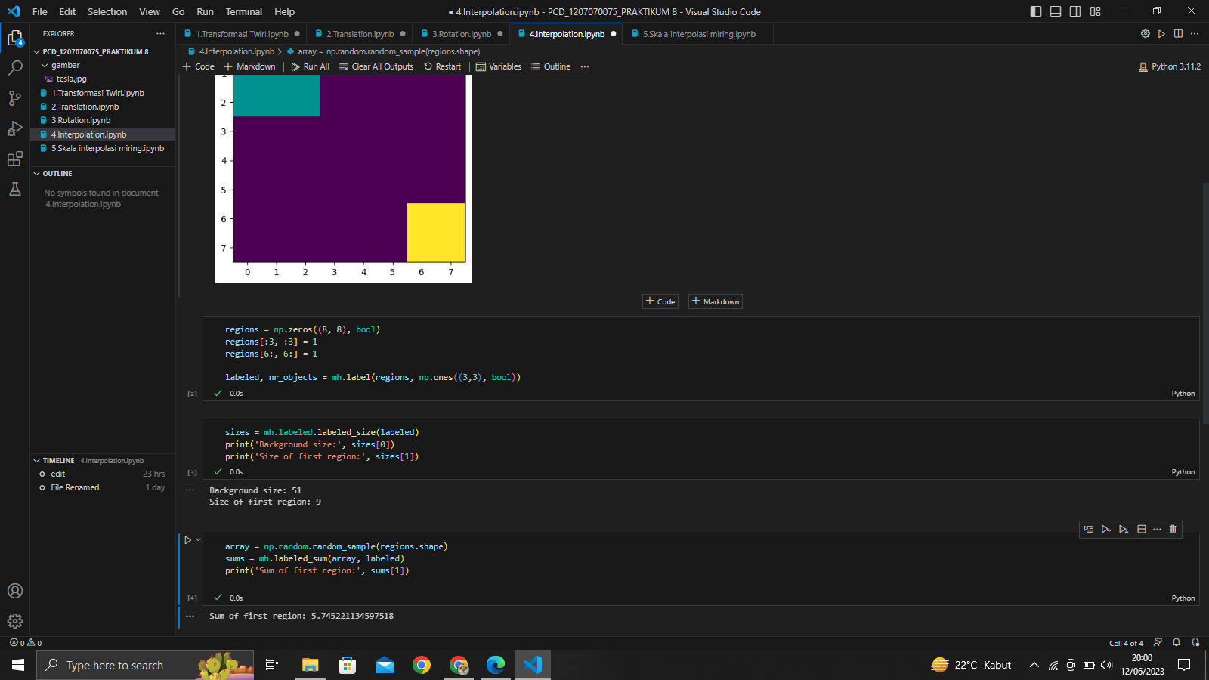

1. Skala Interpolasi Miring

import cv2 as cv

import numpy as np

import matplotlib.pyplot as plt

image = cv.imread("gambar/tesla.jpg")

fig, ax = plt.subplots(1, 3, figsize=(10, 5))

# image size being 0.15 times of its original size

image_scaled = cv.resize(image, None, fx=0.15, fy=0.15)

ax[0].imshow(cv.cvtColor(image_scaled, cv.COLOR_BGR2RGB))

ax[0].set_title("Linear Interpolation Scale")

# image size being 2 times of its original size

image_scaled_2 = cv.resize(image, None, fx=2, fy=2, interpolation=cv.INTER_CUBIC)

ax[1].imshow(cv.cvtColor(image_scaled_2, cv.COLOR_BGR2RGB))

ax[1].set_title("Cubic Interpolation Scale")

# image size being 0.15 times of its original size

image_scaled_3 = cv.resize(image, (200, 400), interpolation=cv.INTER_AREA)

ax[2].imshow(cv.cvtColor(image_scaled_3, cv.COLOR_BGR2RGB))

ax[2].set_title("Skewed Interpolation Scale")

plt.show()

